Khengzore Non-wood forest product management AND Marketing plan
KHAR GEWOG: PEMA GATSHEL
PLAN PERIOD: Sept 2021 – August 2026
First Revision

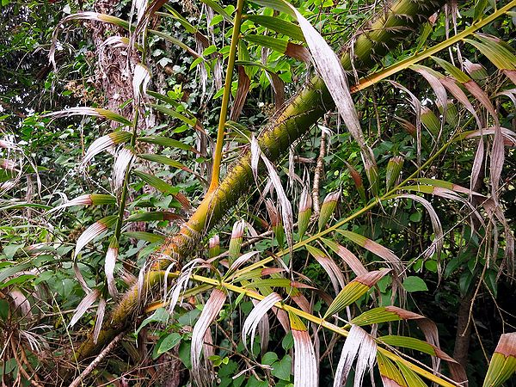
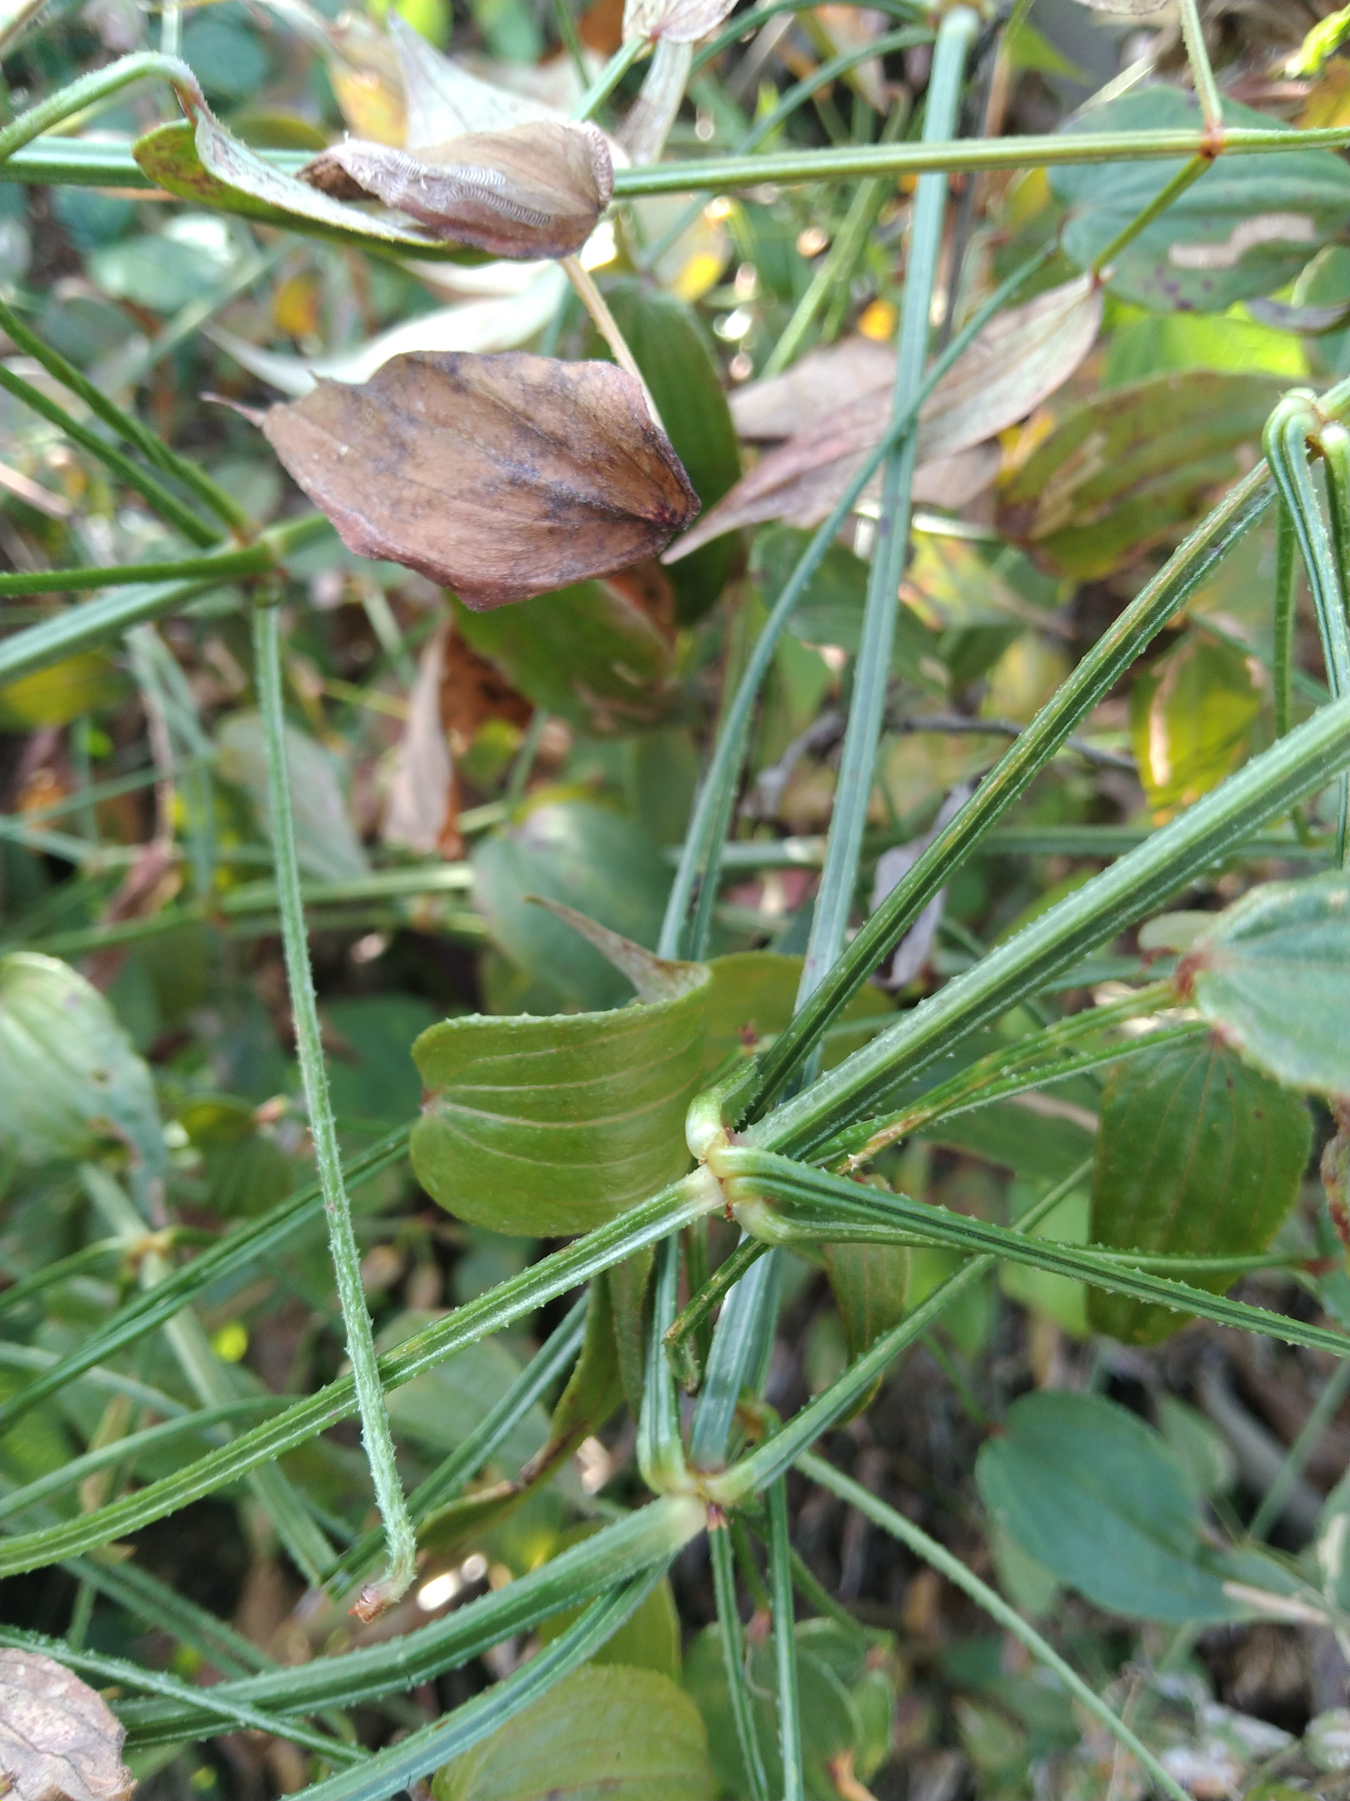
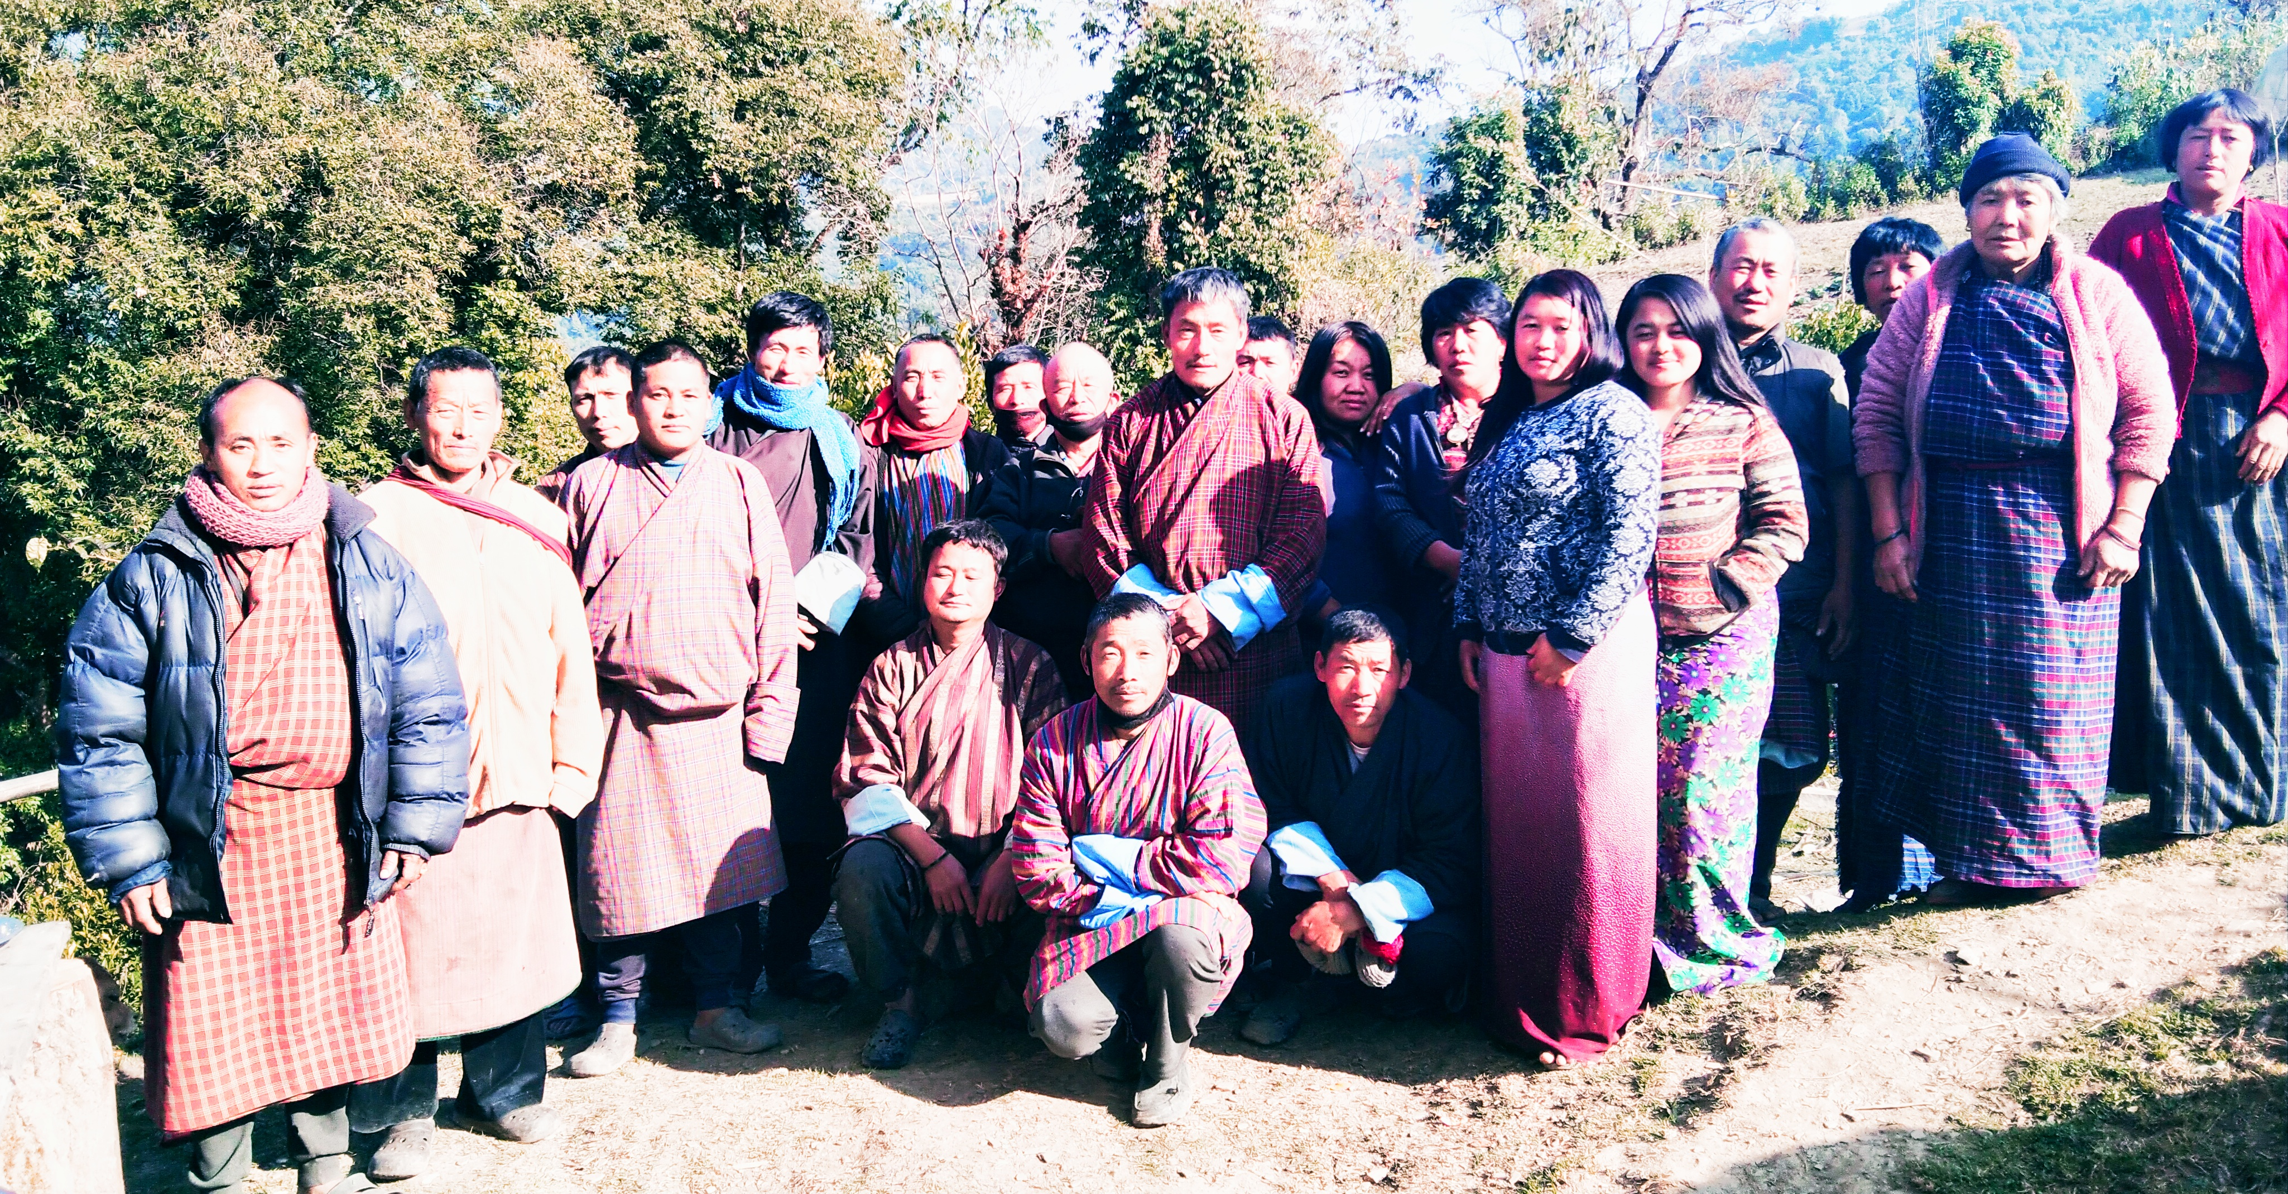
Table of Contents
PART 1: NWFPS MANAGEMENT AND MARKETING PLAN 2
1. Introduction 2
2. The objectives of the management plan 3
3. Description of NWFPs 3
3.1 Short descriptions of Rubia cordifolia (Tshangla Kha: Laniru) 3
3.2 Short description of Plectocomia himalayana(Patsa) 4
3.3 Short descriptions of Elatostema lineolatum (Damru) 4
3.4 Short descriptions of Fiddle head/fern (Nakey/Dawai) 5
4. Harvesting prescriptions for sustainable NWFP harvesting 6
5. Map of the NWFPs collection area. 7
5.1 Google map showing the NWFP collection area 7
5.2 Sketch map of collection area and distribution of NWFP 8
6. Marketing and sales plan 8
Fiddle head 8
(Rashu Dawai) 8
Fiddle head (Ri Dawai) 8
Elatostema lineolatum (Damru) 8
7. Marketing arrangements 9
8. Benefits to the members 9
9. Benefits to the group 9
PART II: BY-LAWS-GROUP REGULATIONS AND NORMS 10
10. Procedures for new membership 10
11. Procedures for leaving the membership 10
12. Responsibilities and rights of members 10
13. Executive committee and their responsibilities 11
13.1 Responsibilities of Chairman 11
13.2 Responsibilities of Secretary 11
13.3 Roles and Responsibilities of Treasurer 11
14. Tenure and benefits for executive committee 11
15. Community Development Fund and utilization of fund 12
16. Conflict Resolution 12
17. Penalties 13
18. Meetings 14
19. Amendment of the gropup’s By-laws 14
20. Member list 15

GLOSSARY AND ABBREVIATIONS
CDF Community Development Fund
CFO Chief Forest Officer
SFED Social Forestry and Extension Division
SRFL Sate Reserved Forest Land
DoFPS Department of Forests and Park Services
DT Dzongkhag Tshogdue
GRO Gewog Range Officer
HHs Households
NWFPs Non-Wood Forest Products
ToR Terms of Reference

PART 1: NWFPS MANAGEMENT AND MARKETING PLAN

1. Introduction
Khengzore is located at an altitude of about 1500 meters to 1800 meters above the sea level under Khar gewog. The village is at about 30 kilometers from Dzongkhag Administration (Denchi) and about 27 kilometers from Gewog center. The village is connected by farm road and has access to all the basic amenities such as Renewable Natural Resources services, health and education. There are 47 households in the village. However, the Khengzore Non Wood Forest Products (NWFP) Management Group is formed by 37 interested members.
In the forest area designated for management, NWFP species such as Plectocomia himalayana, Daphne spp, Elatostema spp, ferns, Rubia cordifolia and Pouzolzia spp. are found. However, during earlier plan period the group collected and sold only Rubia cordifolia and income generated from it has helped the farmers and school going children.
During this plan period also the group will collect Rubia cordifolia as main resource and other if demand arises. The resources were included in the plan to safeguard resources from over exploitation by bringing it under proper management regime. The Rubia cordifolia is commonly found in their fallow privately registered land and in shrub forest of State Reserved Forest Land. Similarly, the fiddle head and Elatostema spp can be also collected from nearby forest. However, to harvest the C. acanthospathus, they have to walk about 2 hours from their village. All the NWFPs species are somewhat abound in the natural forest and has potential for improving livelihood of the member households once it gains market.
The Management plan consist of three parts: The part I which consist of descriptions of those important species, harvesting prescriptions, maps of NWFPs harvesting areas; Part II consist of marketing plan and benefits sharing and finally the Part III which consist of By-laws of the management plan. The By-law describes the roles and responsibility of executive committee and members, conflict resolution and penalties.
The term of management plan is for 5 years and will be effective from September, 2021 to August, 2026. During the plan period, the members will have right to collect mentioned NWFPs as per the harvesting guidelines prescribed in the plan and ensure sustainability of resources in the future.

2. The objectives of the management plan
- Sustainable harvesting of NWFPs listed in the management plan.
- Generate income from sale of NWFP products.
- Ensure equitable benefits sharing among members.

3. Description of NWFPs
The group will harvest four species of NWFPs for commercial purpose. The species to be harvested and its traditional uses are here under.

3.1: Short descriptions of Rubia cordifolia (Tshangla Kha: Laniru)
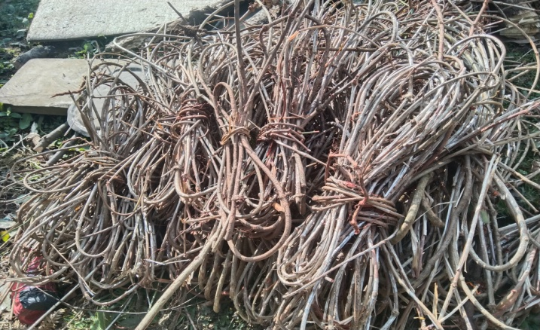
Rubia cordifolia is climbing or creeping perennial herb with stem up to 10 meters long, with woody, long, cylindrical, flexuous roots with thin red bark; stem branched, with long internodes. The species has wide ecological adaptability. It is found in forest edges and clearing, shrub vegetation and dune forest. In the village, the species was found distributed
Photo 01: Rubia cordifolia made into bundles
throughout the villages thereby making easy and accessible for farmers to harvest. The roots and stem are harvested exclusively from the wild and from their land by the farmers and exported as one of the source of income for their livelihood.
Uses
The species is dye-producing plant which is harvested for processing dyes. The species is also known for medicinal values. It is used for treating wounds or cuts to stop bleeding as an antiseptic. The roots are used to as an emetic in case of stomach problems, to treat inflammation of the mammary glands in cattle and to cure itchy skin in human.

3.2: Short description of Plectocomia himalayana(Patsa)

Plectocomia Himalayana is a spiny, evergreen, climbing palm producing cluster of stems that can climb high in to surrounding trees. In Bhutan, the plant is harvested from the forest for local use such as food, source of material for handicrafts and ropes etc. The plan is found in certain location of village where they have to walk about 2 hours to harvest the products. The species is usually found in broad-leaved hill forest, in degraded or
Photo 02: A matured P.himalayana
disturbed areas.
Uses
It is used for handicraft production. The terminal shoots are consumed as vegetable and is bitter in taste. It is one of the Bhutanese delicacies served during especial occasions. The cane part is also used as a raw material for making rope and rough basket. Through proper management system it can be another source of income for the farmers.

3.3: Short descriptions of Elatostema lineolatum (Damru)
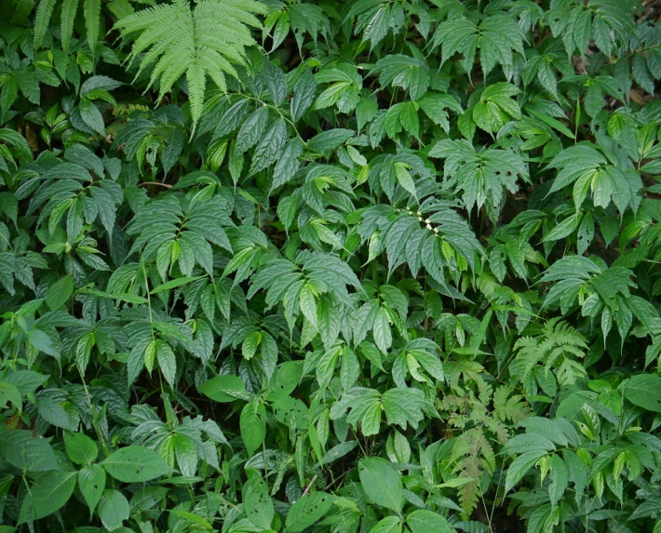
Elatostema lineolatum which is locally known as ‘Damru’ belong to the family of the stinging nettles (Urticaceae) but they don’t have any stinging properties. It is medium size herb about 30 centimetres in height. The leaves are greenish to greyish colour. It is collected for home consumption
Photo 03: A patch of Elastostema lineolatum
as well sale in market to generate income. Small bundles of the Damru is sold usually for Nu.25/- to Nu.30/-. Therefore, it can be another good source of income for the farmers and the group in particular.
Uses
Elsewhere, Elatostema lineolatum is said to have lots of medicinal values which helps build immunity and is usually recommended for anaemic patients. However, in Bhutan the villagers collect it either for sale or for household consumption vegetables. The “Damru soup” is one the delicacy served for the guest and in the family and during grant celebration.

3.4: Short descriptions of Fiddle head/fern (Nakey/Dawai)
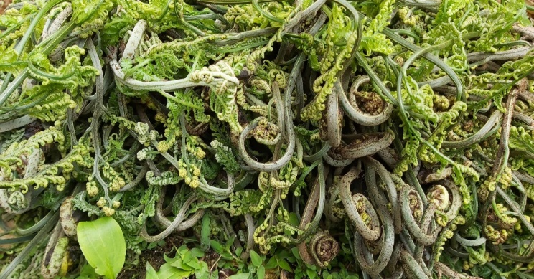
Among the diverse spp of ferns available in the forest the local collects two species. In dzongkha it is called ‘Pangkey’ and ‘Nakey’. However, local call it Rashu Dawai and Ri Dawai. It is harvested in the month of February to April and which are harvested from May to September annually for household consumption or for sale.
Photo o4: Harvested fiddle head made into bundles
Many love it due to its taste, availability, and texture and health benefits. It is said that fiddlehead fetches Nu.25 to Nu.30/- per bundles. The collection and sale of these species has provided additional income source to the farmers.
Uses
Locals consumed it as vegetables. It is also sold in road sides and urban hotels as it is considered as unique delicacies. They dry it and used in preparing Nakey kam Datsi’ ‘Beef Paa’ and ‘Pork paa’ and serve to customers as delicacy.

Table 1: Collection site and NWFP parts and quantity to be harvested
NWFP name | Name of Collection area | Parts harvested | Use purpose (traditional and others) | Harvesting season (months) | Estimated annual quantity to be collected
Rubia cordifolia  (Laniru) | Maksam, Kunzim, Dorji ri, Langzor, Goisang mo, Yingri, Zejab, Langchu poktor | Mainly the stem | Dyes | December - February | 1500 Kg in a year
Plectocomia himalayana (Patsha) | Serphu | Shoots | Shoot as vegetable | May - September. Cane in winter | 100 Kg
Fiddle Head (fern)  (Rashu Dawai) | Zejab, Joktang boring, Yengri, | Fiddle head | Vegetable | February to April | 100 Kg
Fiddle head (Fern)  (Ri Dawai) | Zejab, Joktang boring, Yengri, Khengzore | Fiddle head | Vegetable | June to September | 400 Kg
Elatostema lineolatum (Damru) | Joktang boring, Zejab, Goisang jab | Stem and leaves | Vegetable | Throughout the year | 200 bundles

4. Harvesting prescriptions for sustainable NWFP harvesting
Table 1: Harvesting prescriptions for sustainable NWFP harvesting
NWFP species | Harvesting prescriptions for sustainable harvesting
Rubia cordifolia (Laniru) | - Cut the stem about 2 inch above the ground without damaging the roots system using sharp knife or object.  - Maintain about 10% of total population in the particular collection site for regeneration and seeding.  - Uprooting of whole plant shall be restricted.  - Collection shall be restricted to collection period mentioned in the plan.
Plectocomia himalayana (Patsha) | - Cut only the shoot for vegetable  - About 10% of total population in particular area will be maintained to prevent depletion of resources.  - Shoot will be collect from cane that does not climb on trees.  - For handicraft purpose cane shall be collected only in winter.
Fiddle head  (Dawai) | - Only fiddle head will be collected.  - Cut the frond (the whole fern leaf, blade and stalk) for better regeneration and better yield.  - Clear the competitor for better regeneration and yield.
Elatostema lineolatum (Damru) | - Do not up root the whole plants to avoid depletion of resources.  - Leave about 20% of the total stems  - Collection shall be facilitated during winter season as it will be difficult during summer as the collection sites are usually infested with leeches.  - It shall be not harvested right from base.

5. Map of the NWFPs collection area.

5.1 Google map showing the NWFP collection area
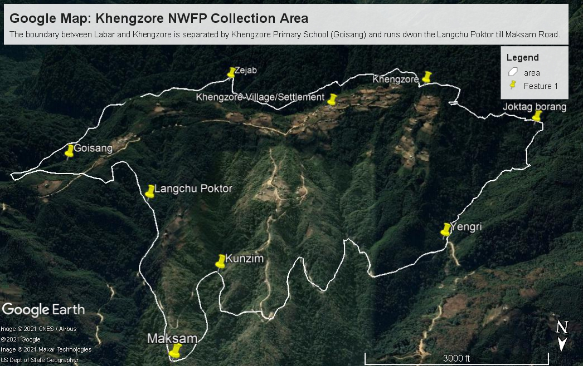

5.2 Sketch map of collection area and distribution of NWFP
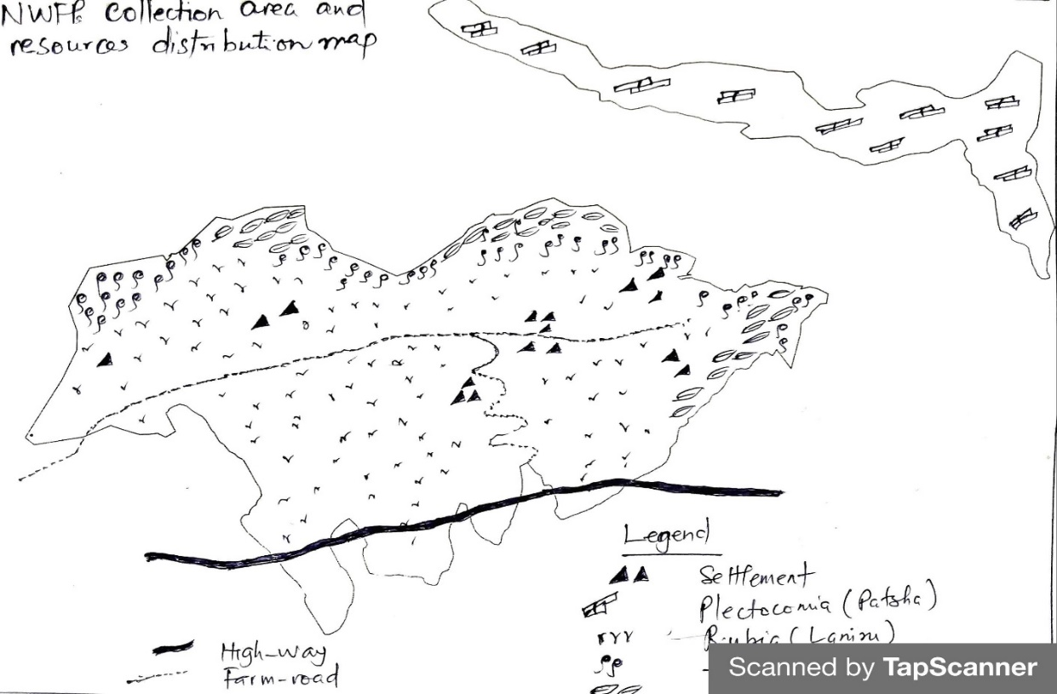

6. Marketing and sales plan
Table 2: Marketing and sales plan of NWFPs
NWFP name | Potential market | Estimated quantity for sale per season | Expected price per unit (Nu) | Total  (Nu.)
Rubia cordifoia (Laniru) | Local trader and Licensed Exporter | 1500 Kgs | 65 | 97,500
Plectocomia himalayana (Patsha) | Local market, and vegetable vendors | 100 Kgs | 100 | 10,000
Fiddle head  (Rashu Dawai) | Local market, and vegetable vendors | 100 Kgs | 20 | 2,000
Fiddle head (Ri Dawai) | Local market, and vegetable vendors | 400 Kgs | 20 | 8,000
Elatostema lineolatum (Damru) | Local trader, local market, and vegetable vendors | 200 bundles | 30 | 6,000

7. Marketing arrangements
Rubia cordifolia (Laniru): The members will collect it individually and carry out post harvest practices as required. The executive committee members will inform the concern forestry official/DAMC on total quantity available for auction and also collect the NWFPs product from the individuals. The concerned forestry official/DAMC will then organize auction in presence of national NWFPs traders. It will be organized in the presence of Chairman of the respective NWFPs group representing the members.
Fiddle head (Dawai) Elatostema lineolatum (Damru), Plectocomia himalayana (Patsha)
The member will harvest only right length fiddles. It will be prepared into bundles and transport to local market. They will refrain from collection fiddles developed into leaves. The executive committee will either collect or instruct individual collector to take for sale.
The executive members may deduct charges incurred on transportation and other compensations prior to the payment to the individual member. The committee responsible will maintain detail record of NWFPs collected from each member and make payment accordingly.

8. Benefits to the members
The members will have equal right for collection and sale of NWFPs. They will be able to make cash income from sale of NWFPs to meet expenses on basic household items like salt, rice, sugar and oil. Further, as few NWFPs collected in winter season, the students can learn about the species and collect to make income to meet their expenses.

9. Benefits to the group
Upon receiving this management plan in hand, the group can collect the various NWFP products legally and sustainably as prescribed. From the 10% compensation, the group will be able to make community welfare fund.

PART II: BY-LAWS-GROUP REGULATIONS AND NORMS
Name of NWFP Group: Khengzore NWFP Management and Marketing Group
Total Membership: 37 Households

10. Procedures for new membership
- The new member should express in writing to the chair person.
- The new member shall be allowed from the family members with Thram and census registered in the village with verification by executive committee and approval from members.
- In order to get equal share from previous fund accrued he/she should pay 70 % of amount eligible to each member.
- Like old member the new member shall contribute membership fee of Nu. 100/- annually.
- The collected fee and fund shall be deposited in the joint account as a CDF.

11. Procedures for leaving the membership
- Any members withdrawing from the group without interest will be allowed without any benefits from the group. However, Childless elderly members leaving the group are entitled to get his/her share from the total fund accumulated.

12. Responsibilities and rights of members
- The group members participating in this management of NWFP will have equal rights and responsibilities for controlling, protection, management and harvesting in the identified collection areas.
- The individual members will have the equal rights to collect and harvest as per prescribed management plan.
- Every member of the group will have equal access to report to the committee members for violation of the management rules.
- The members should responsible to sell collected NWFPs in group.

13. Executive committee and their responsibilities

13.1 Responsibilities of Chairman
Name of Chairman: Mr. Sonam Gyeltshen (Contact #: 17831749)
- To chair all kinds of meeting related to NWFPs management, collection and marketing in the group.
- To resolves the disputes and conflict among the members.
- To enforce the fine and penalty as prescribed in the plan.
- To explore market for the products.
- Fix date of collection and announce to members.
- Coordinate marketing of NWFPs and maintain contacts with traders and other relevant stakeholders.

13.2 Responsibilities of Secretary
Name of Secretary: Mr. Lingthang Norbu (Contact #: 17720941)
- Provide assistance to the Chairman.
- Officiate as Chairperson during his absence.
- Maintain records of the activities implemented, and also minutes of meeting.
- Responsible for writing official correspondence.
- Compile the progress report and submit to the Gewog Forest Range Officer for further submission to Divisional Forest Office.

13.3 Roles and Responsibilities of Treasurer
Name of Treasurer: Mr. Cheki Gyeltshen (Contact #: 17845837)
- Maintain the cash transaction record, submit expenditure and cash balance report to Chairman and present it to the members during meetings.
- Offeciate the Chairperson or Secretary in their absence.
- Collection of membership fee from the group members.
- Issue fine receipt to the offenders.
- Deposit cash collected from the members.

14. Tenure and benefits for executive committee
- The tenure of service for the committee members is for 5 years.
- Anyone representing the NWFP group and attends meetings/important gatherings (Within Pema Gatshel Dzongkhag) will be provided with transportation charges based on recommendation and verification done by Gewog Range Officer. For travel expenses, the individual shall produce following documents dually verified by the Gewog Range Officer and maintain proper record.
- Vehicle number, license number and vehicle type
- Name and CID number of Driver
- Total expenditure incurred/Bills/ cash memo
- Executive committee will be paid Nu.1000/- annually for their service to the group.

15. Community Development Fund and utilization of fund
- The source of community development fund will be from sale of NWFPs products, membership fees and fine and penalties.
- The bank account will be operated by Chairman, Secretary and Treasurer, and they are signatory authority of the Bank Account. However, they will maintain detail record and make it available for monitoring forestry officials and members as and when demanded.
- All expenditure incurred for the group (meeting, purchase of office stationeries and other activities will be met from the group account.
- Technical support will be sought from the concerned Gewog Range Officer (GRO).
- The individual members will deposit 10% of the total amount earned from the sale of any NWFP products irrespective of the price fluctuation and shall be deposited in common CDF Bank.

16. Conflict Resolution
The issues/conflict related to NWFP will be resolved by NWFP executive committee based on their capacities. The unsolved conflict will be forwarded to Gewog Administration through Chairman. Unresolved issues will be forwarded to Divisional Forest Office, Pemagatshel for necessary action.

17. Penalties
Sl No | Activity/Particular | Procedures | Penalty
1 | Meetings/ Labour contribution | Members to cooperate the Executive committee for any NWFP management work and important meeting. | 1st Absentee: Nu. 200/-
 |  |  | 2nd Absentee: Nu.200/-
 |  |  | 3rd Absentee: Expelled from the membership upon unanimous decision of the members.
2 | Collection of NWFP Period | Dec – Feb | If member collect in wrong time, product will be seized by the members and money from sale of product will be deposited in common bank.
3 | Collection site will be within designated boundary. No land owner shall have right to claim the ownership of NWFPs. | Registered land and State Reserved Forest Land. | If private land owner restrict the collection of NWFP claiming the ownership, the owner shall pay the fine of Nu.215/- to all the registered members.
4 | Non-members collecting the NWFP in their NWFP area. | No Non-members will be permitted to collect the NWFPs. | The products will be seized and will be fined as per the FNCRR-2017.
5 | Deployment of Non-member during harvesting of NWFPs. | No deployment of labor will be entertained as a replacement to collect the NWFPs. | The product shall be seized and fined Nu.2000/- per head count.
6 | Sale of products without approval and idea of executive committee. | Sale of product should be through open auction. | The offender shall be terminated from membership permanently.

18. Meetings
The meeting will be conducted during collection of NWFPs, after collection of the products and during sale of products and as when necessary. The secretary will maintain the minutes of the meeting.

19. Amendment of the gropup’s By-laws
The by-laws will be amended based on the needs to resolve issues, problems and constraints to consultation with Gewog Range Officer and approval from Divisional Forest Office. The chairman will write to the Department through concerned forest office stating the reason for need for amendment of by-laws.

20. Member list
